Chapter 18
Portfolio Performance Evaluation

- a. Possibly. Alpha alone does not determine which portfolio has a larger Sharpe ratio. Sharpe measure is the primary factor, since it tells us the real return per unit of risk. We only invest if the Sharpe measure is higher. The standard deviation of an investment and its correlation with the benchmark are also important. Thus positive alpha is not a sufficient condition for a managed portfolio to offer a higher Sharpe measure than the passive benchmark.
b. Yes. It is possible for a positive alpha to exist, but the Sharpe measure decline. Thus, we would experience inferior performance.

- Maybe. Provided the addition of funds creates an efficient frontier with the existing investments, and assuming the Sharpe measure increases, the answer is yes. Otherwise, no.

- The M-squared is an equivalent representation of the Sharpe measure, with the added difference of providing a risk-adjusted measure of performance that can be easily interpreted as a differential return relative to a benchmark. Thus, it provides the same information as the Sharpe measure. But in a different format.

- Definitely, the FF model. Research shows that passive investments (e.g., a market index portfolio) will appear to have a zero alpha when evaluated using the multi-index model but not using the single-index one. The nonzero alpha appears even in the absence of superior performance. Thus, the single-index alpha can be misleading.

 | E(r) | σ | β
Portfolio A | 11% | 10% | 0.8
Portfolio B | 14% | 31% | 1.5
Market index | 12% | 20% | 1.0
Risk-free asset | 6% | 0% | 0.0
The alphas for the two portfolios are:
α_{A} = 11% – [6% + 0.8(12% – 6%)] = 0.2%
α_{B} = 14% – [6% + 1.5(12% – 6%)] = –1.0%
Ideally, you would want to take a long position in Portfolio A and a short position in Portfolio B.

  - If you hold only one of the two portfolios, then the Sharpe measure is the appropriate criterion:
S_{A} = 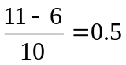
S_{B} = 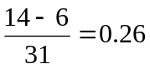
Therefore, using the Sharpe criterion, Portfolio A is preferred.

- We first distinguish between timing ability and selection ability. The intercept of the scatter diagram is a measure of stock selection ability. If the manager tends to have a positive excess return even when the market’s performance is merely “neutral” (i.e., the market has zero excess return) then we conclude that the manager has, on average, made good stock picks. In other words, stock selection must be the source of the positive excess returns.

Timing ability is indicated by the curvature of the plotted line. Lines that become steeper as you move to the right of the graph show good timing ability. The steeper slope shows that the manager maintained higher portfolio sensitivity to market swings (i.e., a higher beta) in periods when the market performed well. This ability to choose more market-sensitive securities in anticipation of market upturns is the essence of good timing. In contrast, a declining slope as you move to the right indicates that the portfolio was more sensitive to the market when the market performed poorly, and less sensitive to the market when the market performed well. This indicates poor timing.
We can therefore classify performance ability for the four managers as follows:
 | Selection Ability | Timing Ability
A | Bad | Good
B | Good | Good
C | Good | Bad
D | Bad | Bad

  - Actual: (0.70 × 2.0%) + (0.20 × 1.0%) + (0.10 × 0.5%) = 1.65%
Bogey: (0.60 × 2.5%) + (0.30 × 1.2%) + (0.10 × 0.5%) = 1.91%
Underperformance = 1.91% – 1.65% = 0.26%

  - Security Selection:
Market | Portfolio Performance |  | Index Performance | Excess Performance | Manager’s Portfolio Weight | Contribution
Equity | 2.0% |  | 2.5% | -0.5% | 0.70 | -0.35%
Bonds | 1.0% |  | 1.2% | -0.2% | 0.20 | -0.04%
Cash | 0.5% |  | 0.5% | 0.0% | 0.10 | 0.00%
 |  | Contribution of security selection: |  |  |  | -0.39%

  - Asset Allocation:
Market | Actual Weight | Benchmark Weight | Excess Weight | Index Return Minus Bogey | Contribution
Equity | 0.70 | 0.60 | 0.10 | 0.59% | 0.059%
Bonds | 0.20 | 0.30 | -0.10 | -0.71% | 0.071%
Cash | 0.10 | 0.10 | 0.00 | -1.41% | 0.000%
 |  | Contribution of asset allocation: |  |  | 0.130%

Summary
Security selection | -0.39%
Asset allocation | 0.13%
Excess performance | -0.26%

- Support: A manager could be a better forecaster in one scenario than another. For example, a high-beta manager will do better in up markets and worse in down markets. Therefore, we should observe performance over an entire cycle. Also, to the extent that observing a manager over an entire cycle increases the number of observations, it would improve the reliability of the measurement.
Contradict: If we adequately control for exposure to the market (i.e., adjust for beta), then market performance should not affect the relative performance of individual managers. It is therefore not necessary to wait for an entire market cycle to pass before you evaluate a manager.

- It does, to some degree. If those manager groups are sufficiently homogeneous with respect to style, then relative performance is a decent benchmark. However, one would like to be able to adjust for the additional variation in style or risk choice that remains among managers in any comparison group. In addition, investors might prefer an "investable" alternative such as a passive index to which they can compare a manager's performance. After all, passive investors do not have the choice of investing in "the median manager," since the identity of that manager is not known until after the investment period.

- The manager’s alpha is: 10% – [6% + 0.5(14% – 6%)] = 0

The spreadsheet below displays the monthly returns and excess returns for the Vanguard U.S. Growth Fund, the Vanguard U.S. Value Fund and the S&P 500.

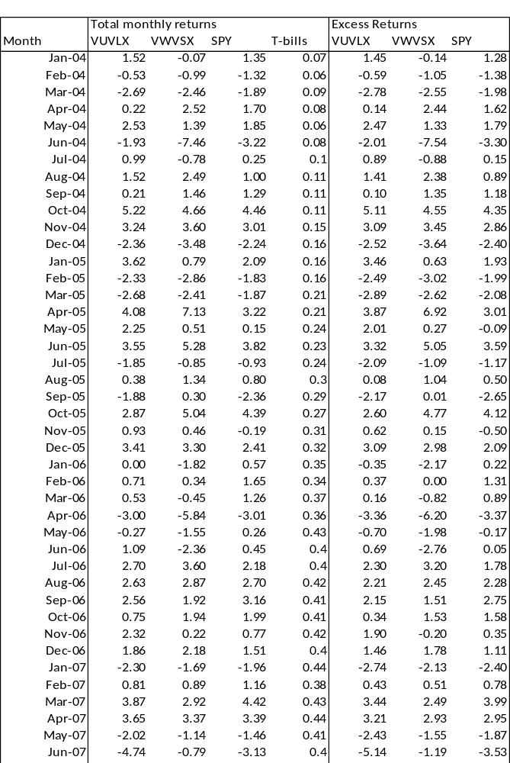
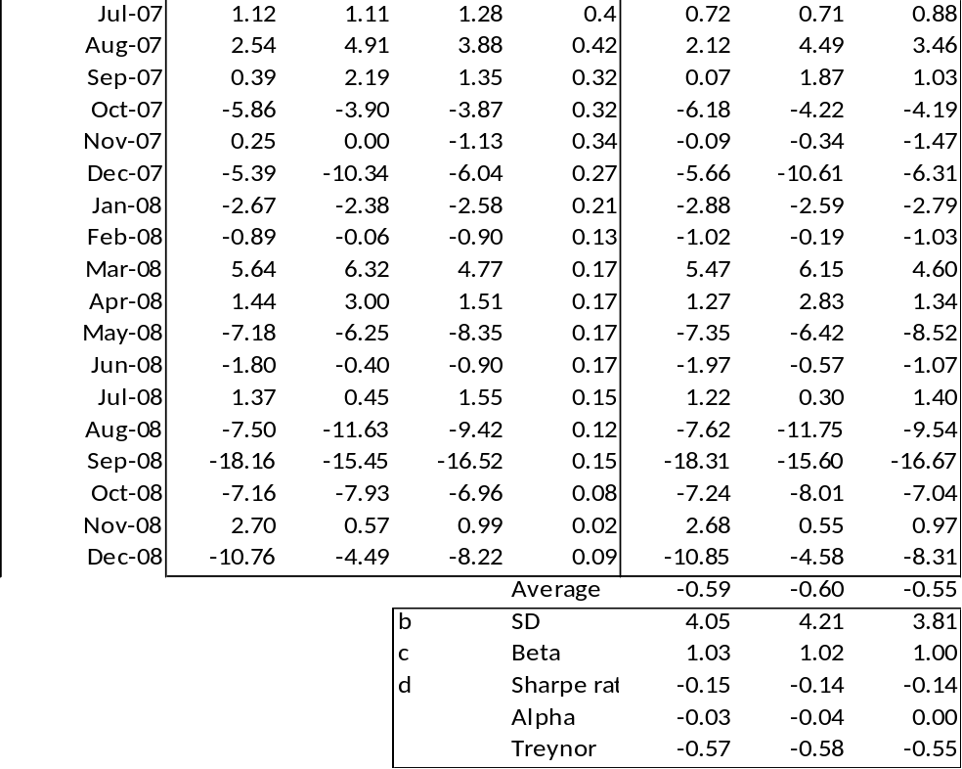

- The excess returns are noted in the spreadsheet.

- The standard deviations for the U.S Growth Fund and the U.S. Value Fund are 4.21% and 4.05%, respectively, as shown in the Excel spreadsheet above.

- The betas for the U.S. Growth Fund and the U.S. Value Fund are 1.02 and 1.03, respectively, as shown in the Excel spreadsheets below.
- The formulas for the three measures are below and results listed above.

Sharpe: 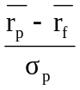
Treynor: 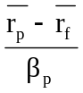
Jensen: 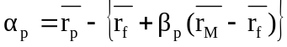
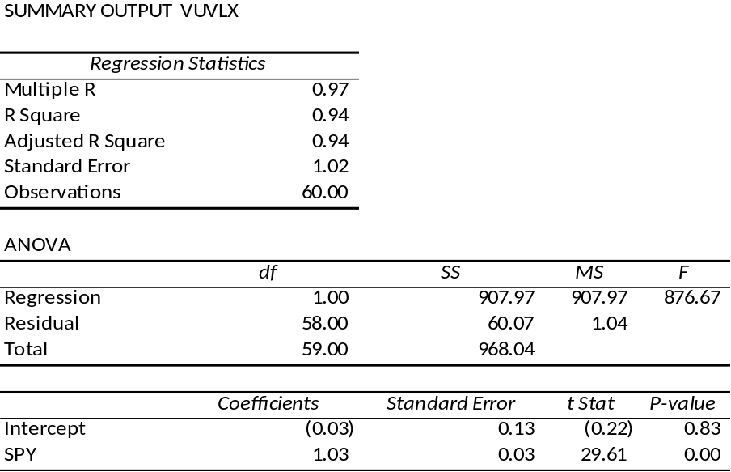

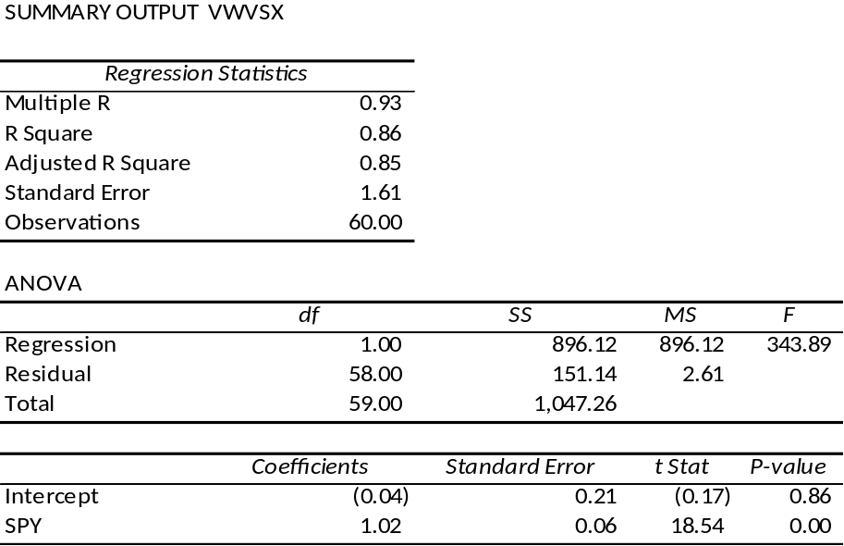

- See the Black-Scholes formula. Substitute:
Current stock price = S₀ = $1.0
Exercise price = X = (1 + r_{f}) = 1.01
Standard deviation = σ = 0.055
Risk-free interest rate = r_{f} = 0.01
Time to maturity of option = T = 1
Recall that ln(l + y) is approximately equal to y, for small y, and that
N(–x) = [1 – N(x)]. Then the value of a call option on $1 of the equity portfolio, with exercise price X = (1 + r_{f} ), is:
C = 2N(σ/2) – 1
N(σ/2) is the cumulative standard normal density for the value of half the standard deviation of the equity portfolio.
C = 2N(0.0275) – 1
Interpolating from the standard normal table:
C = 2[0.5080 + 0.375(0.5160 – 0.5080)] – 1 = 0.0220 = 2.2%
Hence the added value of a perfect timing strategy is 2.2% per month.

  - Using the relative frequencies to estimate the conditional probabilities P₁ and P₂ for timers A and B, we find:
 | Timer A | Timer B
P₁ | 78/135 = 0.58 | 86/135 = 0.64
P₂ | 57/92 = 0.62 | 50/92 = 0.54
P* = P₁ + P₂ - 1 | 0.20 | 0.18
The data suggest that timer A is the better forecaster.

  - Use the following equation and the answer to Problem 13 to value the imperfect timing services of Timer A and Timer B:
C(P* ) = C(P₁ + P₂ – 1)
C_{A}(P* ) = 2.2% × 0.20 = 0.44% per month
C_{B}(P* ) = 2.2% × 0.18 = 0.40% per month
Timer B's added value is greater by 4 basis points per month.

CFA 1
Answer: d

CFA 2
Using a financial calculator or spreadsheet the rate of return is 16.8%

CFA 3
Using a financial calculator or spreadsheet the internal rate of return is 7.5%

CFA 4
  - α_{A} = 24% – [12% + 1.0(21% – 12%)] = 3.0%
α_{B} = 30% – [12% + 1.5(21% – 12%)] = 4.5%
T_{A} = (24 – 12)/1 = 12
T_{B} = (30 – 12)/1.5 = 12
As an addition to a passive diversified portfolio, both A and B are candidates because they both have positive alphas.

  - i. The managers may have been trying to time the market. In that case, the SCL of the portfolios may be non-linear. (ii) One year of data is too small a sample.(iii) The portfolios may have significantly different levels of diversification. If both have the same risk-adjusted return, the less diversified portfolio has a higher exposure to risk because of its higher diversifiable risk. Since the above measure adjusts for systematic risk only, it does not tell the entire story.

CFA 5
  - Indeed, the one year results were terrible, but one year is a poor statistical base from which to draw inferences. Moreover, the fund manager was directed to adopt a long-term horizon. The Board specifically instructed the investment manager to give priority to long term results.
  - The sample of pension funds held a much larger share in equities compared to the Alpine pension fund. The stock and bond indexes indicate that equity returns significantly exceeded bond returns. The Alpine fund manager was explicitly directed to hold down risk, investing at most 25% of fund assets in common stocks. (Alpine’s beta was also somewhat defensive.) Alpine should not be held responsible for an asset allocation policy dictated by the client.
  - Over the five-year period, Alpine’s alpha, which measures risk-adjusted performance compared to the market, was positive:
α = 13.3% – [7.5% + 0.9(13.8% – 7.5%)] = 0.13%
  - Note that, over the last five years, and particularly the last one year, bond performance has been poor; this is significant because this is the asset class that Alpine had been encouraged to hold. Within this asset class, however, the Alpine fund fared much better than the index, as shown in the last two lines of the table. Moreover, despite the fact that the bond index underperformed both the actuarial return and T-bills, the Alpine fund outperformed both for the five-year period. On a risk-adjusted basis, Alpine’s performance within each asset class has been superior. The overall disappointing returns were the result of the heavy asset allocation weighting towards bonds, which was the Board’s, not the fund manager’s, choice.
  - A trustee may not care about the time-weighted return, but that return is more indicative of the manager’s performance. After all, the manager has no control over the cash inflow to the fund.

CFA 6

Alpha (α) | Expected excess return
α i = ri – [r_{f} + βi(r_{M} – r_{f} ) ] | E(ri ) – r_{f}
α_{A} = 20% – [8% + 1.3(16% – 8%)] = 1.6% | 20% – 8% = 12%
α_{B} = 18% – [8% + 1.8(16% – 8%)] = – 4.4% | 18% – 8% = 10%
α_{C} = 17% – [8% + 0.7(16% – 8%)] = 3.4% | 17% – 8% = 9%
α_{D} = 12% – [8% + 1.0(16% – 8%)] = – 4.0% | 12% – 8% = 4%
Stocks A and C have positive alphas, whereas stocks B and D have negative alphas.
The residual variances are:
σ²(e_{A}) = 58² = 3364
σ²(e_{B}) = 71² = 5041
σ²(e_{C}) = 60² = 3600
σ²(e_{D}) = 55² = 3025

- To construct the optimal risky portfolio, we first determine the optimal active portfolio. Using the Treynor-Black technique, we construct the active portfolio:
A | .000476 | –0.6142
B | –.000873 | 1.1265
C | .000944 | –1.2181

D | –.001322 | 1.7058
Total | –.000775 | 1.0000
Do not be disturbed by the fact that the positive alpha stocks get negative weights and vice versa. The entire position in the active portfolio will turn out to be negative, returning everything to good order.
With these weights, the forecast for the active portfolio is:
α = [–0.6142 × 1.6] + [1.1265 × (– 4.4)] – [1.2181 × 3.4] + [1.7058 × (– 4.0)] = –16.90%
β = [–0.6142 × 1.3] + [1.1265 × 1.8] – [1.2181 × 0.70] + [1.7058 × 1] = 2.08
The high beta (higher than any individual beta) results from the short positions in the relatively low beta stocks and the long positions in the relatively high beta stocks.
σ²(e) = [(–0.6142)² × 3364] + [1.1265² × 5041] + [(–1.2181)² × 3600] + [1.7058² × 3025]
= 21809.6
σ(e) = 147.68%
Here, again, the levered position in stock B [with the high σ²(e)] overcomes the diversification effect, and results in a high residual standard deviation. The optimal risky portfolio has a proportion w* in the active portfolio, computed as follows:
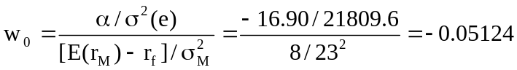
The negative position is justified for the reason given earlier.
The adjustment for beta is:
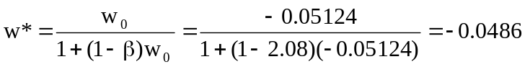

Because w* is negative, we end up with a positive position in stocks with positive alphas and vice versa. The position in the index portfolio is:
1 – (–0.0486) = 1.0486

- To calculate Sharpe's measure for the optimal risky portfolio we compute the appraisal ratio for the active portfolio and Sharpe's measure for the market portfolio. The appraisal ratio of the active portfolio is:
A = α /σ(e)= –16.90/147.68 = –0.1144
A² = 0.0131
Hence, the square of Sharpe's measure (S) of the optimized risky portfolio is:
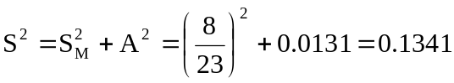
S = 0.3662
Compare this to the market's Sharpe measure:
S_{M} = 8/23 = 0.3478
The difference is: 0.0184
Note that the only-moderate improvement in performance results from the fact that only a small position is taken in the active portfolio A because of its large residual variance.
We calculate the "Modigliani-squared" (M²) measure, as follows:
E(r_{P}*) = r_{f} + S_{P} σ_{M} = 8% + (0.3662 × 23%) = 16.423%
M² = E(r_{P}*) – E(r_{M}) = 16.423% – 16% = 0.423%

